Pre_Landing:
Input: (Raw_Transactions, Raw_Products, Raw_Payments) (Json)
{
"transaction_id": "T20212311",
"customer": {
"cust_id": 3195,
"name": "Customer_3195",
"contacts": [
{
"type": "email",
"value": "customer3195@example.com"
},
{
"type": "phone",
"value": "9941500568"
}
]
},
"items": [
{
"Produkt_ID": "84692512-2066-4162-a693-55aa2e636099",
"Produktname": "Tablet_136",
"Menge": 3,
"Einheitspreis": 58112.11
},
{
"Produkt_ID": "e3ed9555-ff91-4926-8666-562189ea63d0",
"Produktname": "Router_866",
"Menge": 1,
"Einheitspreis": 58276.37
},
{
"Produkt_ID": "adbbd3f5-8f61-4e5c-b74f-1cfb801977b3",
"Produktname": "Shoes_153",
"Menge": 3,
"Einheitspreis": 87736.83
},
{
"Produkt_ID": "24a09424-25c9-4a95-9958-55d112058f75",
"Produktname": "Laptop_719",
"Menge": 3,
"Einheitspreis": 36125.74
}
],
"transaction_ts": "2021-10-18T19:35:00Z",
"location": "Mumbai"
}

Output:
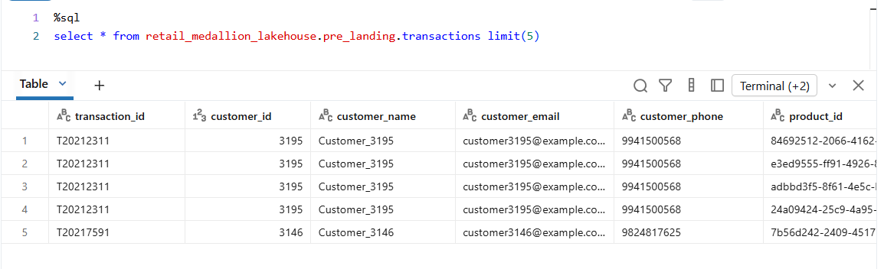
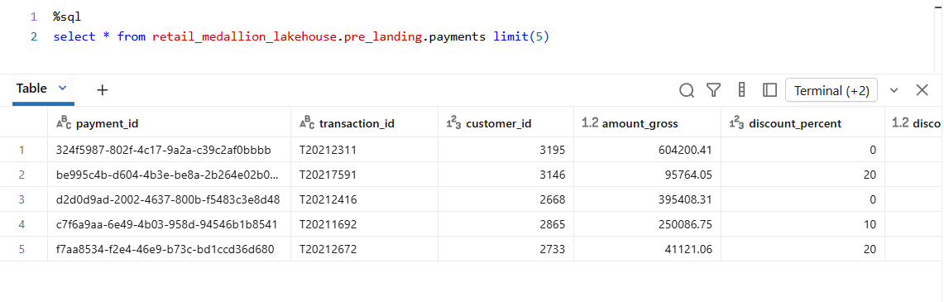
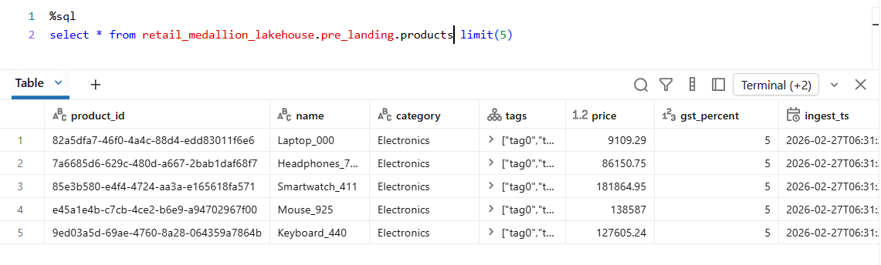
Job Run:
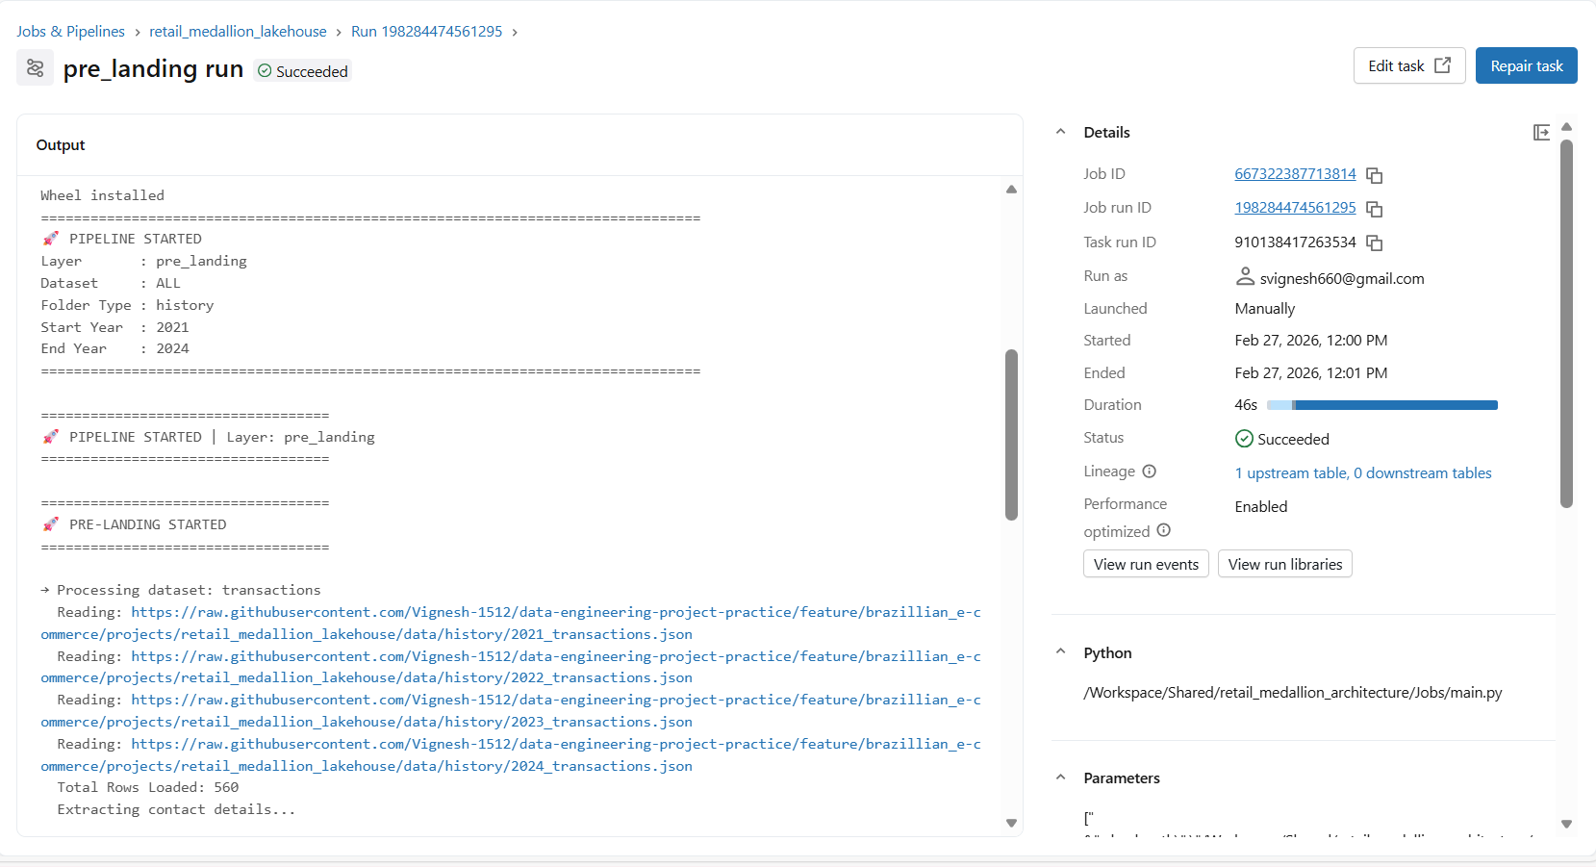

Landing:
Input:
Pre_Landing -> Landing (Partitioned) Partition_Year

Output:
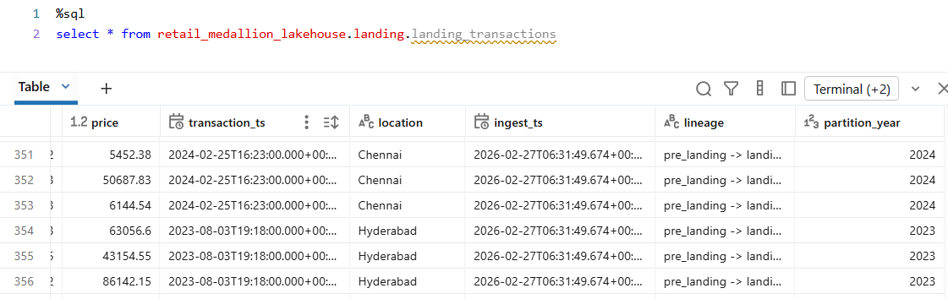

Job Run:
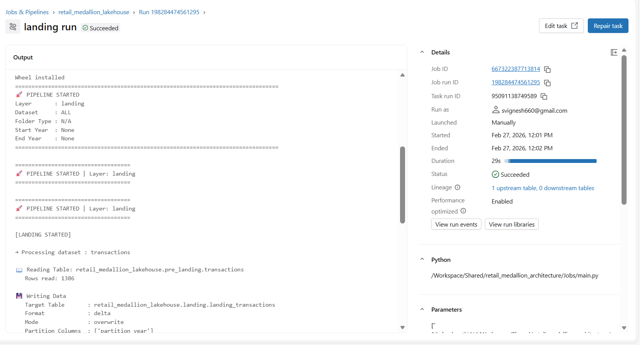

Unification:

Input:
Landing_Transactions + Landing_Payments + Landing_Prodcuts -> Unified_retail (Partition Year)

Output:
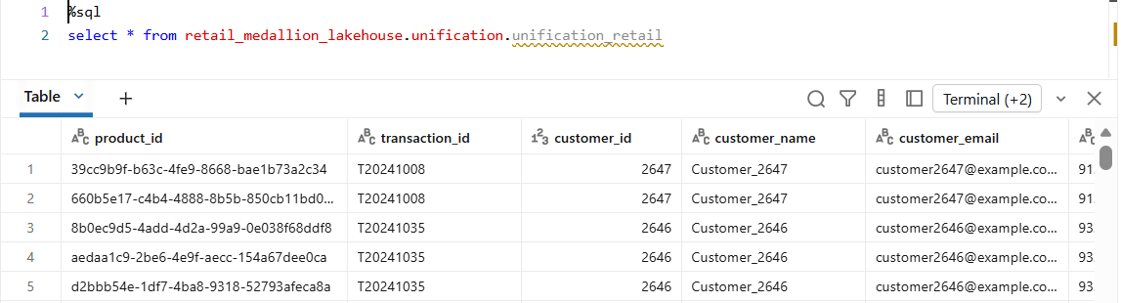
Job Run:
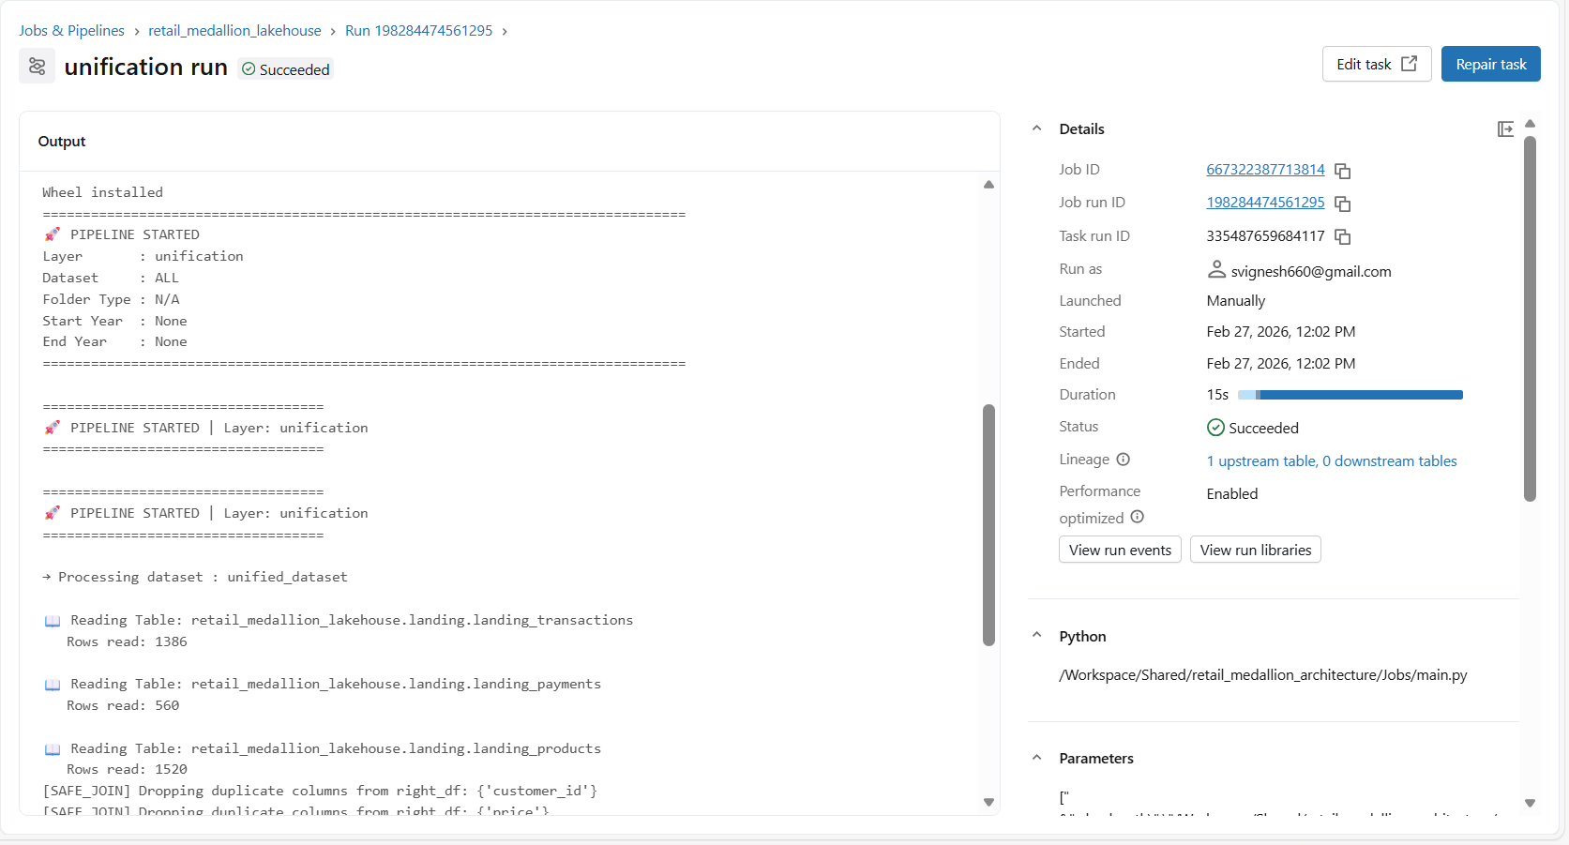

Refinement:
Input:
Unified_retail -> Refined_retail

Output:
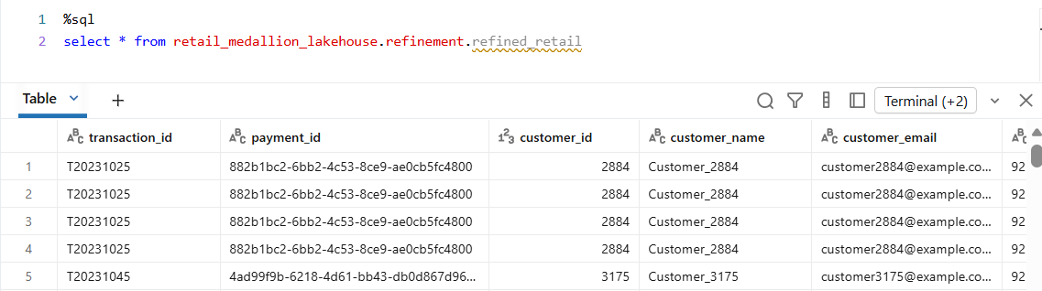
Job Run:
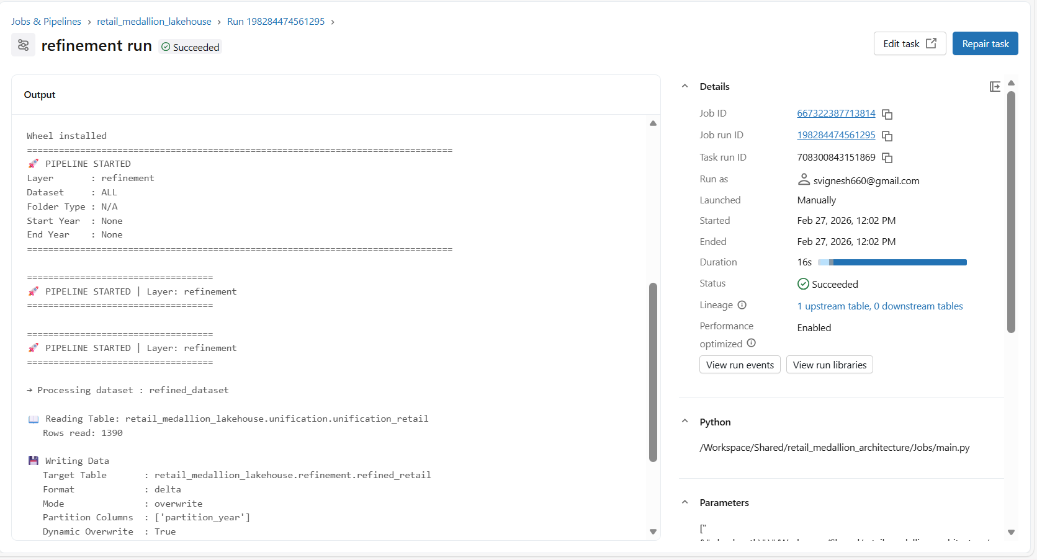

Publish:
Input:
Refined_retail -> Aggregated Tables

Output:
Daily_Sales_Summary:
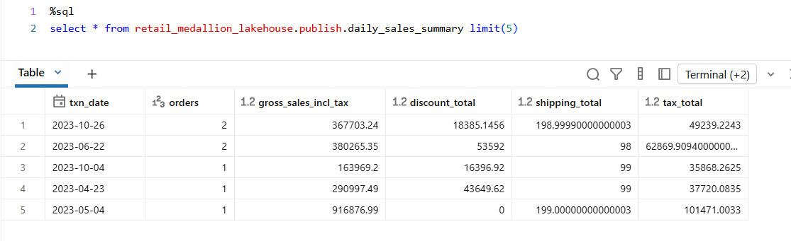
Product_Performance:
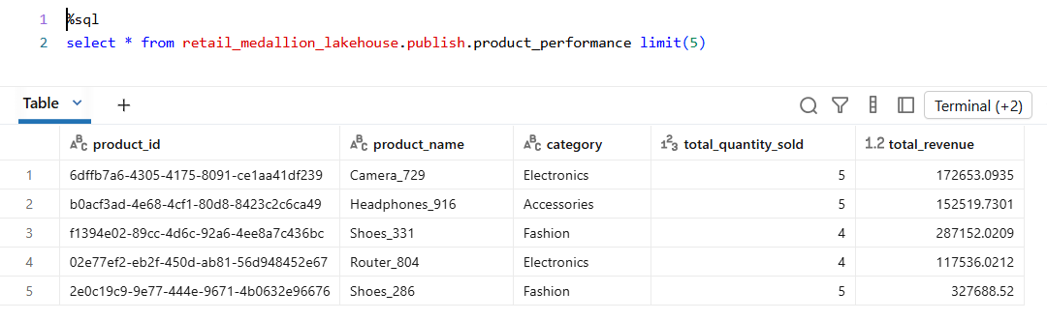
Payment_Success_Rate:
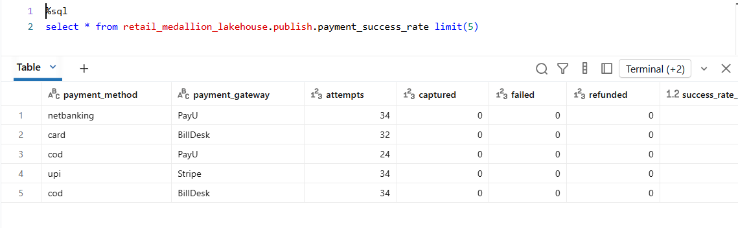
Customer_lifetime_value:
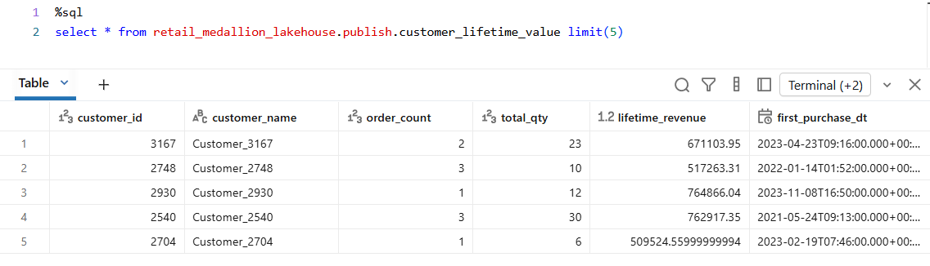
Job Run:
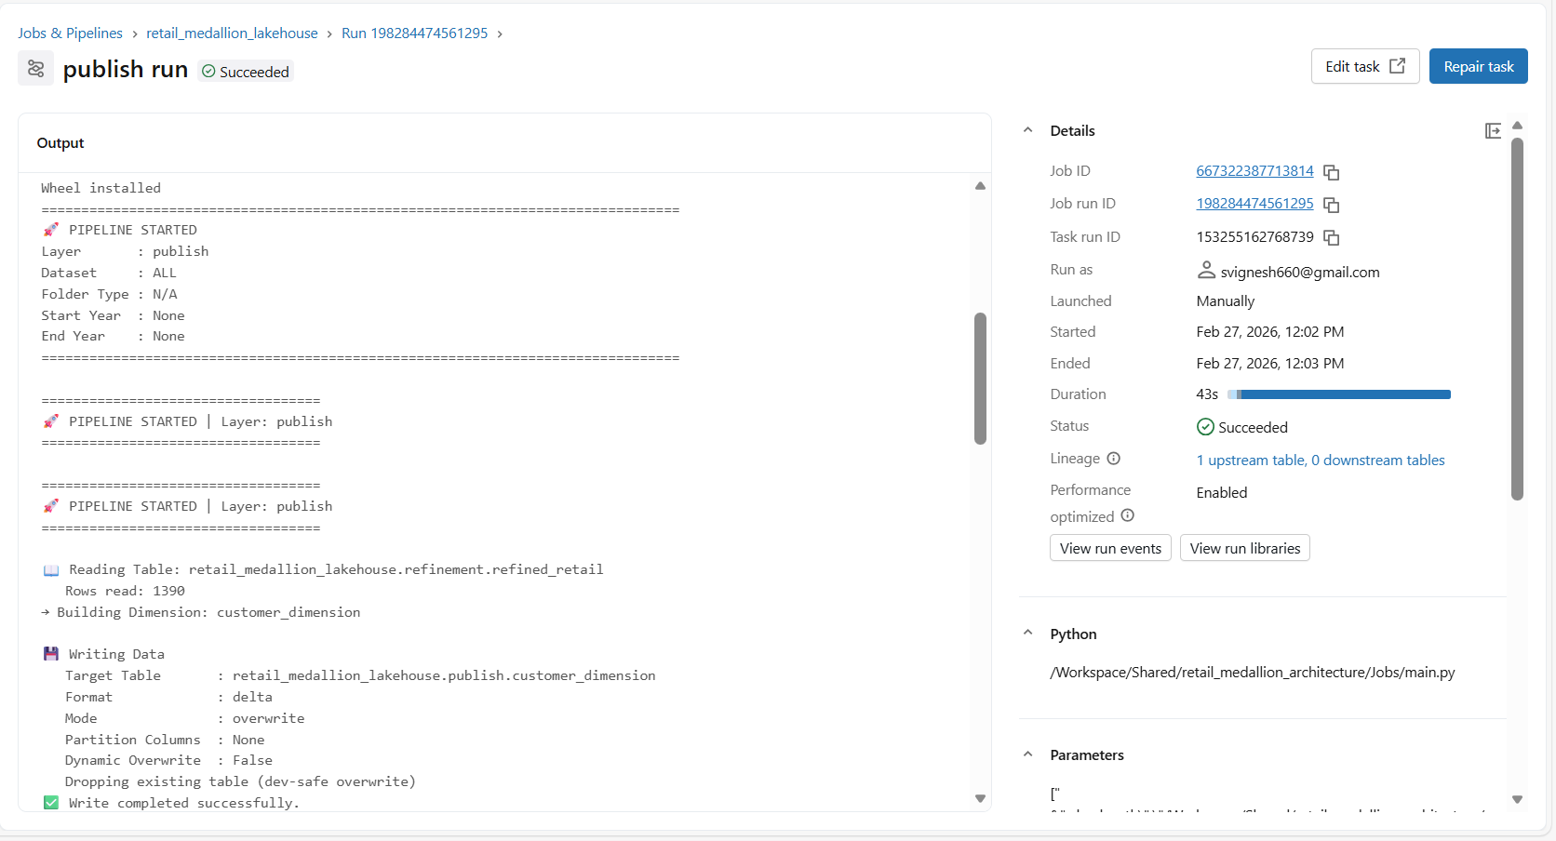
Lineage Graph:
